Project Two README
Grazioso Salvare Rescue Dog Dashboard
Carrie Cummings | CS-340 Client/Server Development | Project Two

About the Project/Project Title
Grazioso Salvare Rescue Dog Dashboard for the Austin Animal Center (AAC) Database
Global Rain, a custom software engineering company, was contracted by Grazioso Salvare, an international rescue-animal training organization, to build a full stack application that helps identify dogs suited for search-and-rescue training. Grazioso Salvare partners with a nonprofit agency that operates five animal shelters around Austin, Texas, and that agency supplies the shelter outcome data used in this project.
Grazioso Salvare looks for specific profiles when selecting dogs. Search-and-rescue training is generally most effective with dogs no older than two years, and certain breeds excel at particular rescue types such as water rescue, mountain or wilderness rescue, disaster rescue, and scent tracking of a specific person. This dashboard lets Grazioso Salvare staff filter the shelter data against those profiles with a single click and see the results in a table, a chart, and a map at the same time.
The application is a three-tier full stack that was built in two phases:
Tier | Technology | Role and Phase
Base (Model) | MongoDB | Stores the 10,000 AAC shelter outcome records with user authentication. Completed in Project One.
Middleware ("Glue") | Python CRUD module | Reusable AnimalShelter class that performs Create, Read, Update, and Delete operations on MongoDB. Completed in Project One and reused without changes in Project Two.
Client (View/Controller) | Dash web framework | Interactive dashboard with rescue-type filters, a data table, a breed pie chart, and a geolocation map. Completed in Project Two (this project).

This README documents Project Two: the client-facing dashboard that sits on top of the MongoDB database and the CRUD Python module from Project One. Per the client's request, the code is open source on GitHub so similar organizations can adapt it, and this README explains both how the dashboard works and how to reproduce it.

Motivation
Project One gave Grazioso Salvare a working database and a reusable module for reaching it, but using either one still required writing Python or MongoDB queries. Grazioso Salvare staff are rescue trainers, not database developers, so they needed a way to find candidate dogs without typing a query. The dashboard turns each rescue profile into a single radio button. One click runs the correct query, and the table, chart, and map all update together. The client asked for an interface that is intuitive and reduces user errors and training time, and this design answers that directly.
The design also supports the client's open-source goal. All three rescue profiles are stored in one Python dictionary (RESCUE_FILTERS), so a partner organization with different breed preferences or age ranges can update the dashboard by editing that one dictionary, without touching the queries, layout, or callbacks.

Getting Started
The following steps reproduce the project from an empty environment. They were performed in the Codio virtual lab (Ubuntu Linux with MongoDB, mongosh, and Jupyter Lab preinstalled), but the same steps work on any machine with the tools listed under Installation.

Project Files
File | Purpose
aac_shelter_outcomes.csv | Source data set (Austin Animal Center outcomes, modified with latitude, longitude, and age in weeks). Located in the datasets folder.
CRUD_Python_Module.py | The reusable CRUD module from Project One containing the AnimalShelter class. Located in code_files.
ProjectTwoDashboard.ipynb | Jupyter Notebook containing the full dashboard: logo, layout, rescue queries, and callbacks. Located in code_files.
Grazioso Salvare Logo.png | Client logo displayed at the top of the dashboard. Located in code_files.

Step-by-Step Reproduction
- Import the data set. From the terminal, load the CSV into a database named aac and a collection named animals. Run this command only one time. Running it again adds a second full copy of every record (see Challenges and Solutions).
mongoimport --port=27017 --db=aac --collection=animals --type=csv \
--headerline --file=/home/codio/workspace/datasets/aac_shelter_outcomes.csv
- Create the application user. Open the shell with mongosh, switch to the admin database, and create aacuser with the readWrite role scoped only to the aac database. The dashboard connects through this limited account rather than an administrator account.
use admin
db.createUser({user: "aacuser", pwd: "<password>",
roles: [{role: "readWrite", db: "aac"}]})
- Verify authentication. Reconnect as the new user against the admin authentication database and run db.runCommand({connectionStatus: 1}) to confirm aacuser holds the readWrite role on aac.
mongosh --port 27017 --authenticationDatabase "admin" -u "aacuser" -p
- Install the Python libraries. If they are not already present, install the driver and dashboard libraries. The Codio lab for this course has them preinstalled.
pip install pymongo pandas dash jupyter-dash dash-leaflet plotly
- Place the files. Save CRUD_Python_Module.py, ProjectTwoDashboard.ipynb, and Grazioso Salvare Logo.png in the same folder (code_files in Codio). The notebook sets its working directory and import path to this folder with os.chdir() and sys.path.insert(), so update that path if a different folder is used.
- Set the credentials. In the Data Manipulation section of the notebook, set username and password to the account created in Step 2. Host, port, database, and collection use the constructor defaults (localhost, 27017, aac, animals).
- Run the dashboard. Open ProjectTwoDashboard.ipynb in Jupyter Lab and select Kernel, then Restart Kernel and Run All Cells. The cell prints "Dash app running on" followed by a link (Figure 6). Open the link to load the dashboard. If port 8050 is already in use, change the last line to app.run_server(port=8051).
- Test the filters. Select each radio item and compare the record counts to the Tests table in the Usage section. The starting state and Reset should both show 10,001 records.
- Save and export. Save the notebook (Ctrl+S), then download the .ipynb and .py files for submission or upload to GitHub.

Installation
Each tool below was chosen for a specific reason tied to the project's requirements.
Tool | Version | What It Does and Why It Was Chosen
MongoDB | 7.0.21 | NoSQL document database and the Model of the application. Chosen because each shelter record is a self-contained JSON-like document that maps directly to a Python dictionary, and its query operators express the rescue profiles exactly as the client described them.
mongosh | 2.5.3 | MongoDB's interactive shell. Used to create the aacuser account, verify authentication, and inspect the collection while troubleshooting.
mongoimport | Bundled tool | Command-line utility that loads all 10,000 CSV records into the animals collection in one command.
Python | 3.11.2 | Language for the entire stack. The CRUD module, the queries, and the Dash dashboard are all written in Python, so the project stays in one language from database to browser.
PyMongo | Latest via pip | MongoDB's official Python driver, used inside the CRUD module. The read() method passes a Python dictionary to find() and returns a list of dictionaries the dashboard can use directly.
Pandas | Codio lab | Converts query results into a DataFrame, drops the _id column, removes duplicate records, and counts breeds for the pie chart.
Dash | Codio lab | Open-source Python web framework from Plotly that provides the View (app.layout) and Controller (callbacks). Chosen because it builds a full interactive web app in pure Python with no separate HTML or JavaScript.
JupyterDash | Codio lab | Runs the Dash app from inside a Jupyter notebook and serves it at a link through the Codio proxy.
Dash DataTable | Codio lab | Interactive table with native paging, sorting, column filtering, and row selection.
Dash Core Components | Codio lab | Provides the RadioItems filter control and the Graph container for the pie chart.
Plotly Express | Codio lab | Builds the breed pie chart from a few lines of code.
Dash Leaflet | Codio lab | Builds the geolocation map with OpenStreetMap tiles, a marker, a tooltip, and a popup.
Jupyter Lab | Codio lab | Notebook environment used to develop, run, and screenshot the dashboard.
Codio | Virtual lab | Cloud development environment with MongoDB and Jupyter preconfigured, so the project runs the same way for every developer.

MongoDB and Dash Technical Details
The following database and framework behaviors shape how the dashboard works.
Why MongoDB is the Model. MongoDB stores data as BSON documents, and PyMongo converts them to and from Python dictionaries automatically. A query is a dictionary going in, and the results are a list of dictionaries coming out, which Pandas turns into a DataFrame in one line with pd.DataFrame.from_records(). MongoDB also has a flexible schema, so the extra fields added to this data set (location_lat, location_long, and age_upon_outcome_in_weeks) required no table changes. User authentication lets the dashboard run under the limited aacuser account, and the database can scale and add indexes if Grazioso Salvare adds more shelters.
Query operators in the rescue filters. Each rescue query combines four conditions with an implicit $and:
- animal_type equal to Dog, using implicit $eq
- $in to match any breed in the preferred breed list
- sex_upon_outcome equal to Intact Male or Intact Female
- $gte and $lte on age_upon_outcome_in_weeks for the training age range
The build_query() function builds these from the RESCUE_FILTERS dictionary. Reset returns an empty filter {}, which matches every document.
The Dash framework. Dash runs on a Flask web server and renders the page in the browser with React, but every component is declared in Python. Dash splits an application into a layout and callbacks, which lines up with the View and Controller in MVC.
app.layout (View). The layout defines what the user sees: the logo wrapped in a link to www.snhu.edu, the dashboard title, the unique identifier, the radio items, the data table, and a side-by-side row holding the pie chart and the map. Each interactive component has an id that the callbacks reference.
Callbacks (Controller). A callback is a Python function decorated with @app.callback that lists its Input and Output component IDs. Dash calls the function automatically whenever an Input changes and sends the return value to the Output. The IDs must match the layout exactly or the callback never fires.
derived_virtual_data. The pie chart and map read the table's derived_virtual_data property instead of the original query results. This property holds the rows currently in the table after any sorting or column filtering, so the widgets stay in sync with exactly what the user is looking at.
Removing the _id column. MongoDB adds an _id field of type ObjectId to every document. ObjectId cannot be converted to JSON, so the DataTable would crash if it were included. The dashboard drops it with df.drop(columns=['_id']) before the data reaches the table.

Usage
Open the dashboard link, then select a rescue type from the radio items at the top of the page. The table, pie chart, and map update immediately. Select Reset to return all widgets to the full, unfiltered data set. Within the table, click a column header to sort, type in the filter row under a header to search that column, use the arrows at the bottom right to page through results, and select a row with the radio button on the left to move the map marker to that animal. Hover over the marker to see the breed, or click it to see the animal's name.

Rescue Filters
The filters are built from the Rescue Type and Preferred Dog Breeds table provided by Grazioso Salvare.
Rescue Type | Preferred Breeds | Preferred Sex | Training Age
Water | Labrador Retriever Mix, Chesapeake Bay Retriever, Newfoundland | Intact Female | 26 to 156 weeks
Mountain or Wilderness | German Shepherd, Alaskan Malamute, Old English Sheepdog, Siberian Husky, Rottweiler | Intact Male | 26 to 156 weeks
Disaster or Individual Tracking | Doberman Pinscher, German Shepherd, Golden Retriever, Bloodhound, Rottweiler | Intact Male | 20 to 300 weeks
Reset | All animals | Any | Any

Dashboard Components
Component | ID | Purpose
Logo (html.A + html.Img) | None | Grazioso Salvare logo linked to www.snhu.edu, per the client's branding requirement.
Unique identifier (html.H4) | unique-id | Credits Carrie Cummings as the developer. Visible in every screenshot.
RadioItems | filter-type | The four filter options. Only one can be selected at a time, which prevents conflicting filters.
DataTable | datatable-id | Interactive table with 10 rows per page, sorting, column filtering, and single row selection.
Pie chart (dcc.Graph) | graph-id | Breed breakdown of the rows currently in the table. The unfiltered view shows the top 10 breeds plus an Other slice.
Map (dl.Map) | map-id | Marker at the selected animal's latitude and longitude, with the breed as a tooltip and the name in a popup.

Callbacks
Callback | Input | Output | What It Does
update_dashboard | filter-type value | Table data, page, and selected row | Builds the rescue query, runs it through the CRUD module's read() method, and resets the table to page 1 with the first row selected.
update_graphs | Table derived_virtual_data | graph-id children | Counts breeds in the current view and returns the pie chart.
update_map | Table derived_virtual_data and selected rows | map-id children | Places the map marker on the selected animal and centers the map on it.
update_styles | Table selected_columns | Table style | Highlights the column the user selects.

Code Example
The controller builds each query from the rescue dictionary and sends it through the Project One CRUD module:
from CRUD_Python_Module import AnimalShelter

# Connect with the aacuser account
shelter = AnimalShelter("aacuser", "<password>")

# Build the Water Rescue query from the RESCUE_FILTERS dictionary
query = build_query("Water")
# {"animal_type": "Dog",
# "breed": {"$in": ["Labrador Retriever Mix", "Chesapeake Bay Retriever", "Newfoundland"]},
# "sex_upon_outcome": "Intact Female",
# "age_upon_outcome_in_weeks": {"$gte": 26, "$lte": 156}}

# Run it through the CRUD module and load the results for the table
df = get_dataframe(query)

Error Handling
The get_dataframe() function wraps every database call in a try/except block, and the CRUD module's read() method catches PyMongoError and returns an empty list on failure. If a query fails or returns no matches, the pie chart and map callbacks display a short message ("No matching animals to chart." or "No matching animals to map.") instead of raising an error. The map callback also falls back to the first row whenever the selected row is out of range after a filter change. If the logo file cannot be found, the dashboard still loads and shows the company name as text.

Tests
The dashboard was tested in three passes. Unit testing ran each rescue query on its own and compared the results to the original CSV file. Integration testing confirmed that every callback fired in the right order, so each filter updated the table, pie chart, and map together. Regression testing went back over the Module Six Milestone features (paging, sorting, column filtering, row selection, and the map marker) to confirm the new code did not break them.
# | Test | Expected | Actual
1 | Starting state loads with Reset selected | 10,001 records, all widgets populated | Pass: 10,001 records (Figure 1)
2 | Water Rescue filter | 17 intact female Labrador Retriever Mixes, 26 to 156 weeks | Pass: 17 records (Figure 2)
3 | Mountain or Wilderness Rescue filter | 5 intact male dogs from the preferred breeds, 26 to 156 weeks | Pass: 5 records (Figure 3)
4 | Disaster Rescue or Individual Tracking filter | 4 intact male dogs from the preferred breeds, 20 to 300 weeks | Pass: 4 records (Figure 4)
5 | Reset filter | All widgets return to the starting state | Pass: matches Figure 1 (Figure 5)
6 | Pie chart and map follow each filter | Breeds and marker match the table | Pass (Figures 1 to 5)
7 | Branding on every view | Logo and unique identifier visible | Pass (Figures 1 to 5)

The 10,001 total is the 10,000 records from the CSV file plus one test document created during Project One testing of the create() method.

Screenshots
Dashboard Execution
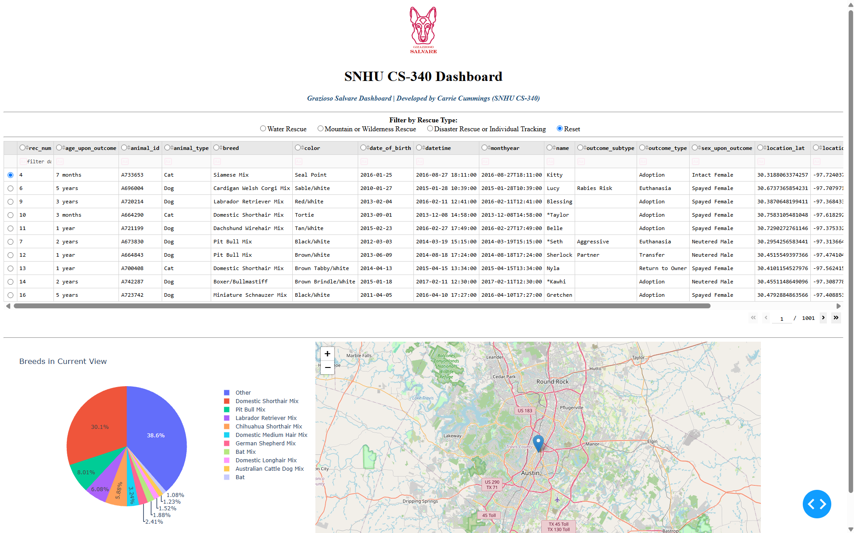
Figure 1: Starting state of the dashboard with Reset selected, showing all 10,001 records, the top 10 breeds in the pie chart, and the map marker on the first row.
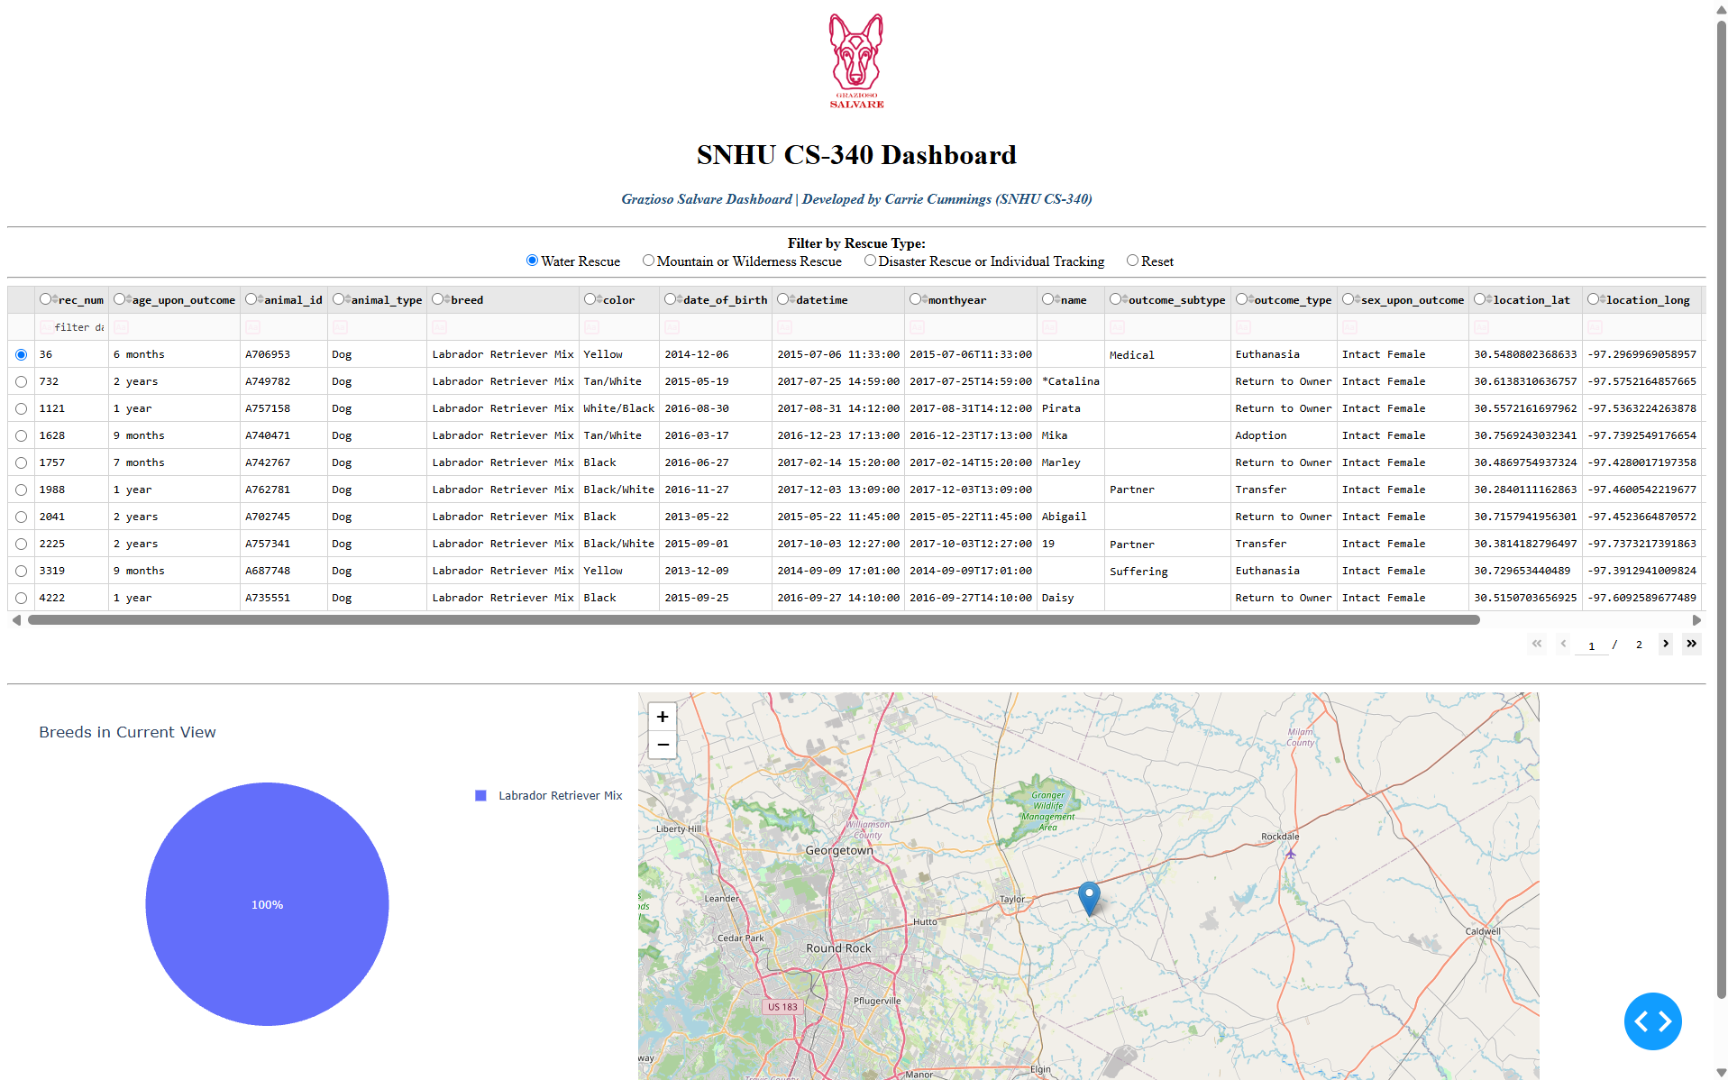
Figure 2: Water Rescue filter applied, returning 17 intact female Labrador Retriever Mixes between 26 and 156 weeks old.
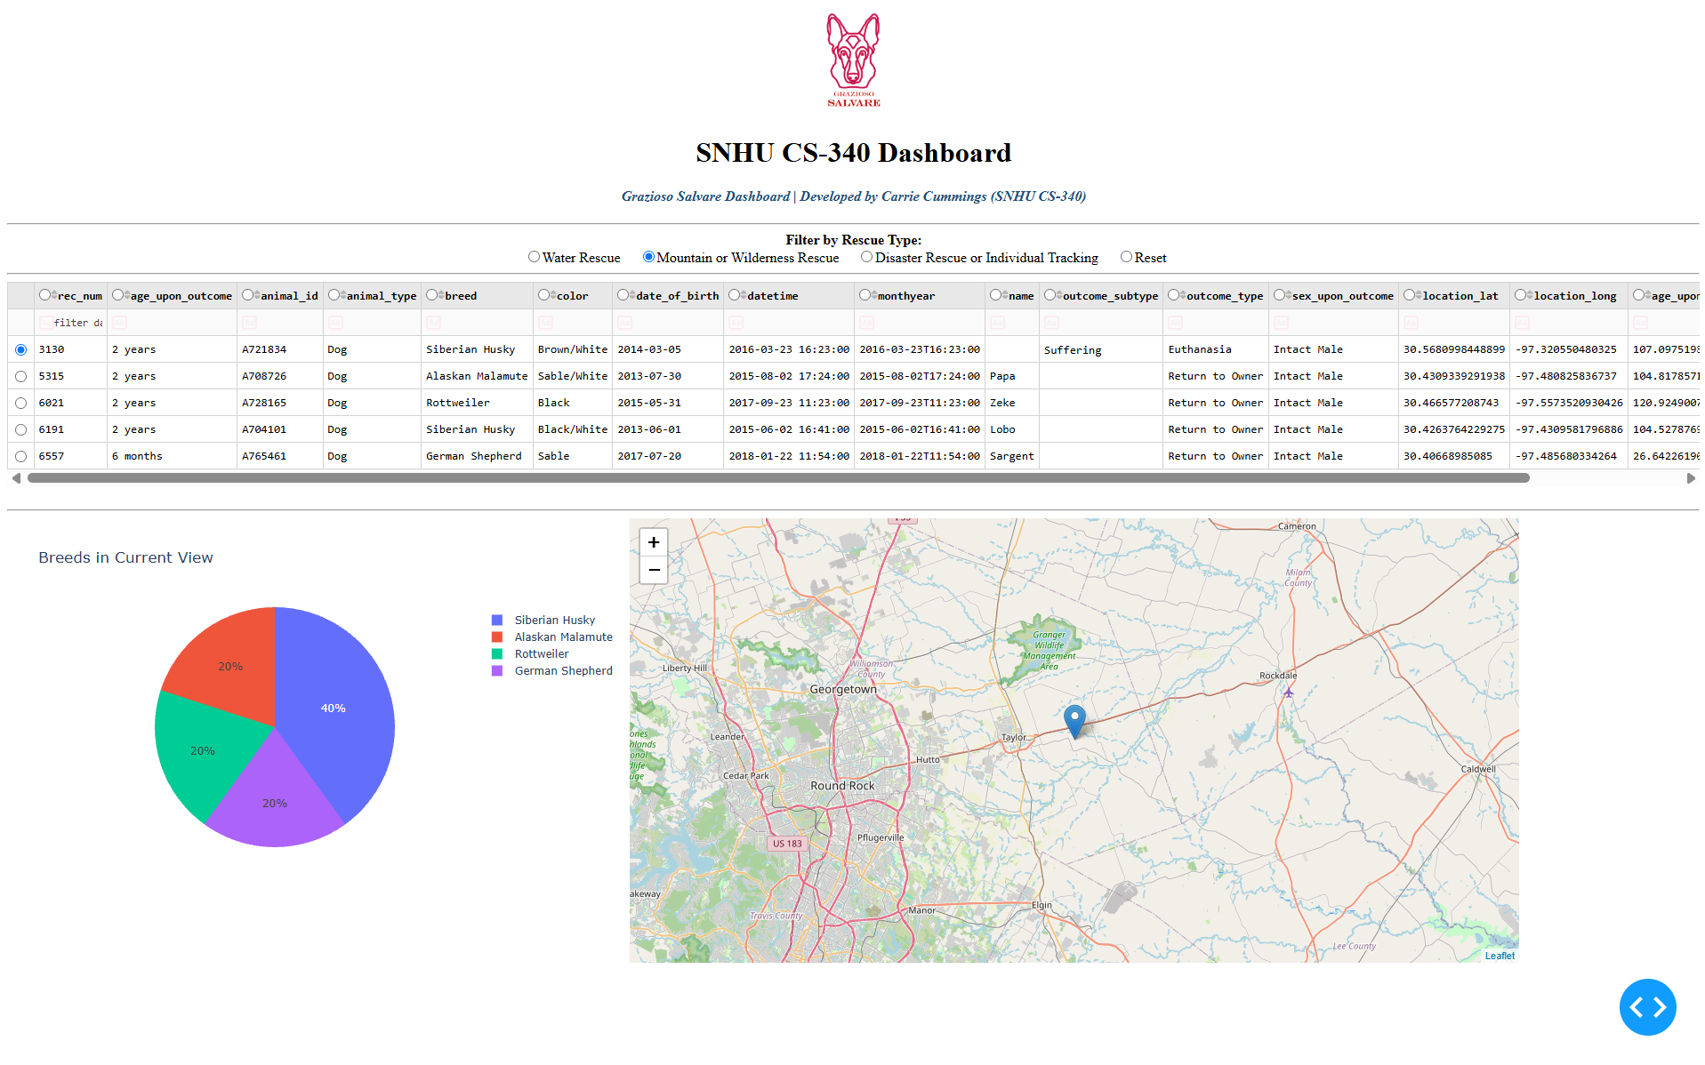
Figure 3: Mountain or Wilderness Rescue filter applied, returning 5 intact male Siberian Huskies, Alaskan Malamutes, Rottweilers, and German Shepherds.
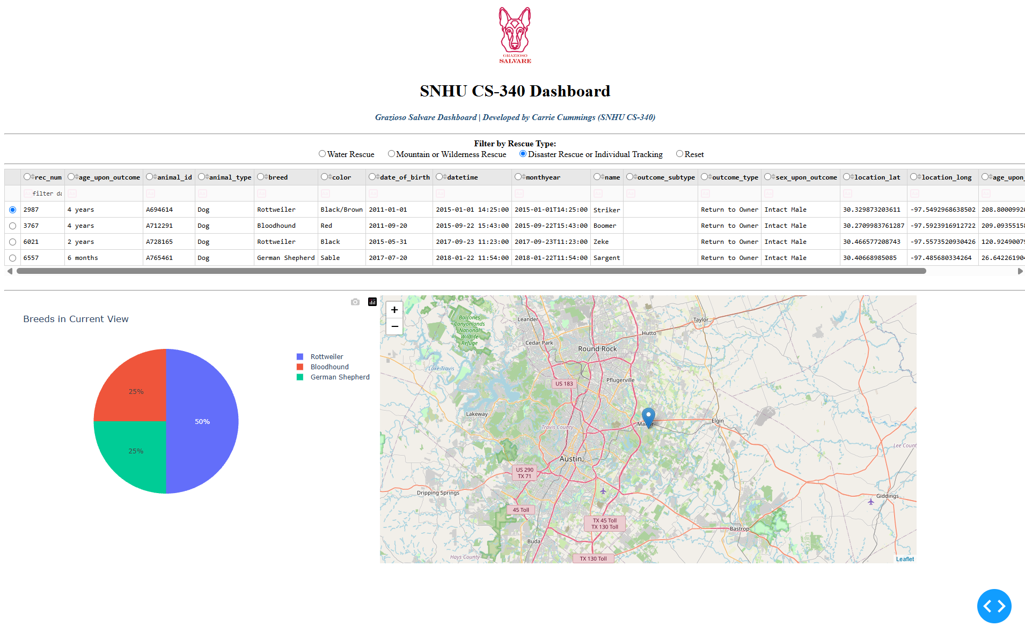
Figure 4: Disaster Rescue or Individual Tracking filter applied, returning 4 intact male Rottweilers, Bloodhounds, and German Shepherds.
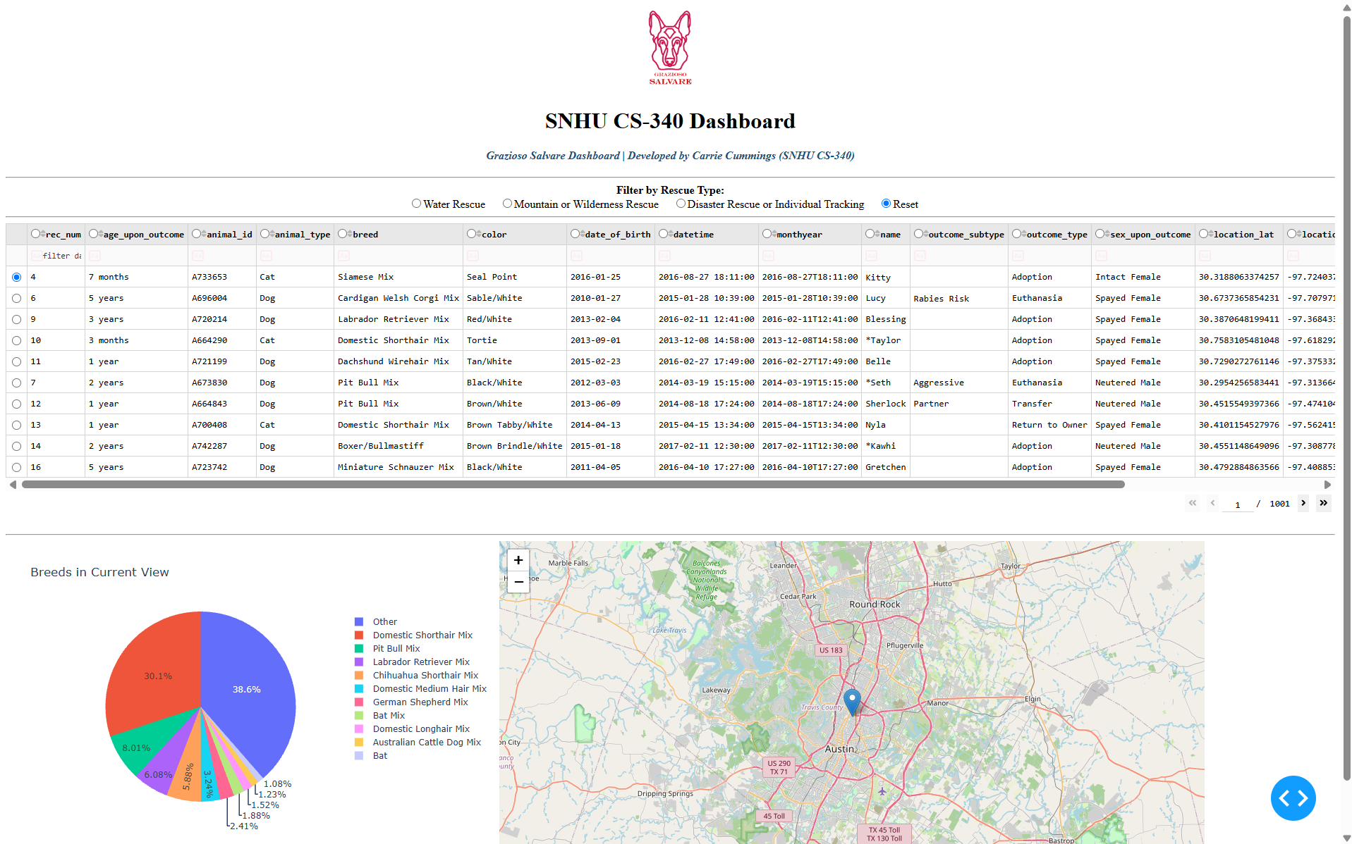
Figure 5: Reset selected, returning every widget to its original unfiltered state.
Code Execution in Jupyter Lab
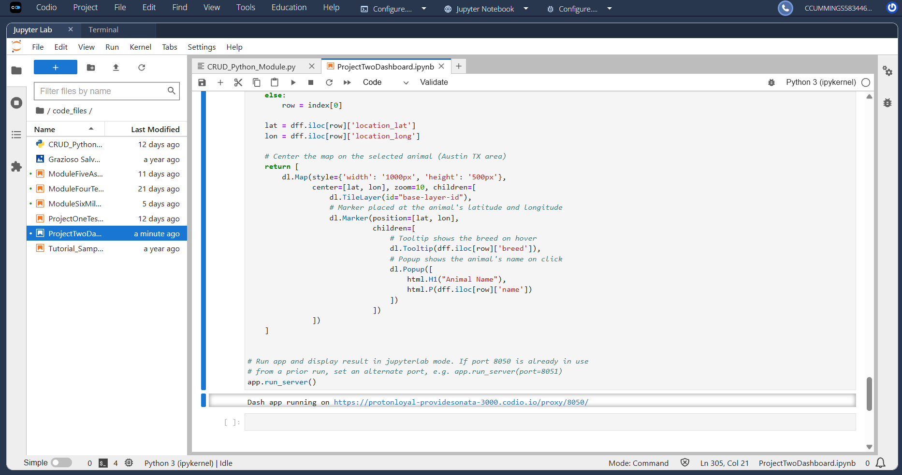
Figure 6: ProjectTwoDashboard.ipynb running in Jupyter Lab on Codio, with the "Dash app running on" link printed below the cell.

Challenges and Solutions
Challenge | Cause | Solution
Duplicate dogs in the table | The data set had been imported into the animals collection three times during earlier modules, so the collection held 30,001 documents and every match appeared three times. | Added drop_duplicates() in Pandas after the _id column is removed. With _id gone, the copies are identical, so only true duplicates are removed. Counts now match the CSV file exactly.
Age range query missing its minimum | A common way of writing the range lists the age_upon_outcome_in_weeks key twice. In a Python dictionary the second key overwrites the first, so only $lte runs. | Placed $gte and $lte inside a single dictionary for that field so MongoDB checks both limits.
Water Rescue returns only one breed | No Chesapeake Bay Retrievers or Newfoundlands in the data set are intact females between 26 and 156 weeks old. | Confirmed against the CSV file that this is a data limitation, not a bug. Matching dogs added later will appear automatically.
Unreadable pie chart in the unfiltered view | The full data set has hundreds of breeds, which would create hundreds of tiny slices. | Showed the 10 most common breeds and grouped the rest into an Other slice. Filtered views still show every breed.
Map pointing at a row that no longer exists | After a filter shrinks the table, the previously selected row number can be past the end of the new results. | The filter callback resets the table to page 1 and selects the first row, and the map callback falls back to the first row if the selection is ever out of range.
Starter button logic | The sample walkthrough compared button click counts, so after one click a user had to click another button twice to switch filters. | Used radio items instead. One selection always equals one active filter.

Software Design
Three-tier architecture. The project separates storage (MongoDB), business logic (the CRUD module), and presentation (the Dash dashboard). The CRUD module from Project One was reused in Project Two without any changes, which confirms that each tier can change without breaking the others.
Model-View-Controller (MVC). MongoDB, accessed through the CRUD module, is the Model. The Dash app.layout is the View, which defines what the user sees. The Dash callbacks are the Controller, which respond to filter selections, call the CRUD module, and send the results back to the View. Project One built the Model, and Project Two completes the View and Controller.
Client/server communication. Dash runs on a Flask web server. When the user selects a filter, the browser sends the new value to the server over HTTP as JSON, the server runs the callback and the MongoDB query, and the updated table data and chart components are sent back to the browser as JSON. This follows the same request and response pattern used by RESTful APIs.
Data-driven configuration. The rescue profiles live in one RESCUE_FILTERS dictionary and a single build_query() function turns any profile into a query. Adding a new rescue type means adding one dictionary entry and one radio option, with no new query code.

Resources
- Austin Animal Center Outcomes data set: https://doi.org/10.26000/025.000001
- MongoDB documentation: https://www.mongodb.com/docs/
- PyMongo documentation: https://pymongo.readthedocs.io/
- Dash documentation: https://dash.plotly.com/
- Dash Core Components: https://dash.plotly.com/dash-core-components
- Dash DataTable: https://dash.plotly.com/datatable
- Dash Leaflet: https://www.dash-leaflet.com/
- Plotly pie charts in Python: https://plotly.com/python/pie-charts/
- Pandas documentation: https://pandas.pydata.org/docs/
- PEP 8 Style Guide for Python Code: https://peps.python.org/pep-0008/
- Giamas, A. (2022). Mastering MongoDB 6.x (3rd ed.). Packt Publishing.

Roadmap
- Map all filtered dogs: Show a marker for every dog in a filtered view, not only the selected row, so trainers can see where all candidates are located.
- Prevent duplicates at the source: Add a unique index on animal_id and datetime so a repeated import is rejected by the database instead of cleaned up in the dashboard.
- Indexes for speed: Add indexes on breed, sex_upon_outcome, and age_upon_outcome_in_weeks so the rescue queries stay fast as more shelters are added.
- Table component update: Plotly now recommends Dash AG Grid over DataTable for new projects, so the table could be migrated in a future version.

Contact
Your name: Carrie Cummings

